Test Plan

Agile Story Sprint-Feature Completion

This Test Plan is identify the checklist of the feature before marking it complete in the Team Sprint.

What Are Agile User Stories?

A user story is the smallest unit of work in an agile framework. It’s an end goal, not a feature, expressed from the software user’s perspective.

The purpose of a user story is articulate how a piece of work will deliver a particular value back to the customer. Note that "customers" don't have to be external end users in the traditional sense, they can also be internal customers or colleagues within your organization who depend on your team.

User stories are a few sentences in simple language that outline the desired outcome. They don't go into detail. Requirements are added later, once agreed upon by the team.

What is a Feature?

A Feature is the unit of the functionality of the software system that satisfies the requirement, represents a design decision and provides a potential configuration option.

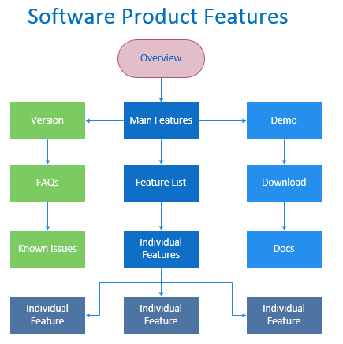

Checklist for Feature Completion

1. Requirements of the Feature

Product features are characteristics of your product that describe its appearance, components, and capabilities. A product feature is a slice of business functionality that has a corresponding benefit or set of benefits for that product's end user.

1. Analysis of the Feature

The first step in replacing outdated legacy software with more powerful tools is understanding what the product needs to do for it to be successful. It could be PDF software that has basic and advanced functionality, so it works for everyone in the business. Or, it could be as simple as needing applications that work in Windows 10 without glitches or lag-time. If existing software can't tick all of the boxes, then it is time to rethink and refresh your existing software.

Draw up a feature comparison table to evaluate different products and features. Once the information is plotted it's possible there may be a clear winner. If not, add weighting to the features that are most likely to enhance productivity. Look for opportunities to streamline and simplify without disrupting users. Remember, it is often possible to trial software before committing to purchase, so be sure to take advantage of this.

1. Impacts of the Feature

Feature creep (also known as requirements creep or scope creep) is the tendency for product features or project requirements to increase during development, beyond those originally foreseen.

Feature creep also suggests an ongoing behavior where the addition of new features are performed without consideration to the original project goals and without corresponding increases to the project budget or schedule.

1. Business Protocols of the Feature

Underlying **business rules** provide guidance to an organisation or company, while**business requirements** state a high-level future state that will achieve a **business rule**, opportunity or need. **Business rules** tell you what you may or may not do something. They might also provide criteria or conditions for making decisions.

1. Feature Interaction

A feature interaction is a situation in which two or more features exhibit unexpected behavior that does not occur when the features are used in isolation.

1. Risks of the Feature

What would be the risks of the feature after releasing it? Impacts would help to identify the risks. Make a mitigation plan of the risks. Assumptions and Business rules of the feature would help in analysing the risk.

1. Post Implementation

Are there any technical requirements or dependency of any components on the feature? Is this feature dependent on another feature or it can work independently?